**Challenges Faced – Infinite Loop:**

Here is my code which is causing an infinite loop

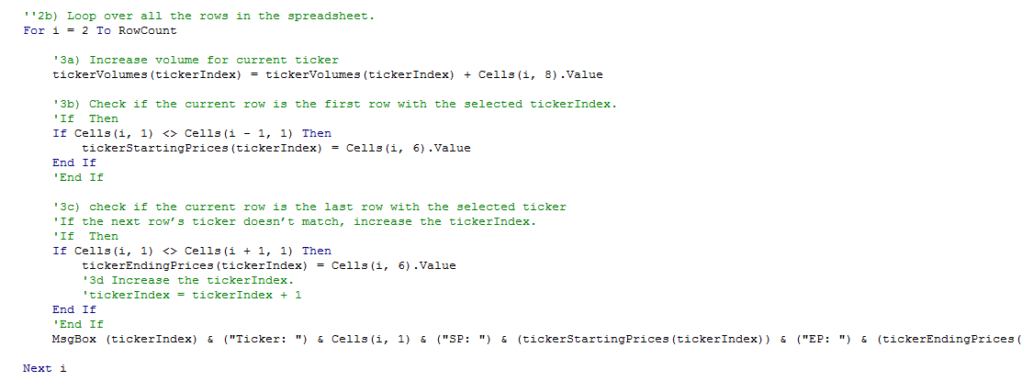

I’ve created a copy of the 2018 data tab which is what I’ve been trying to run the code on and have inserted the code in the form of the formulas

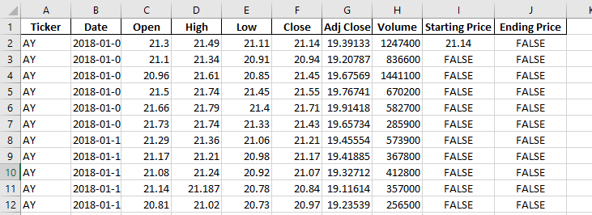

If I replace i with the iteration of the loop, I don’t understand why I am stuck in an infinite loop

If we compare the code to my duplicated Excel sheet (named 2018 (2)) this is how I’d expect it to execute

|  |  |
| --- | --- |
| **Code** | **Expected Execution (can be visualized in Excel)** |
| **2b)** For i = 2 to rowCount | Where i = 2 |
| **3b)** If Cells(i, 1) <> Cells(i - 1, 1) Then  tickerStartingPrices(tickerIndex) = Cells(i, 6).Value  End If | This formula returns TRUE therefore  tickerStartingPrice = 21.14  if statement ends because it was true |
| **3c)** If Cells(i, 1) <> Cells(i + 1, 1) Then  tickerEndingPrices(tickerIndex) = Cells(i, 6).Value  **3d)** Increase the tickerIndex.  tickerIndex = tickerIndex + 1  End If | This formula returns false  Therefore this does not execute  Nor this this, so the index remains 0  The if statement ends because it is false |
| MsgBox (tickerIndex) & ("Ticker: ") & Cells(i, 1) & ("SP: ") & (tickerStartingPrices(tickerIndex)) & ("EP: ") & (tickerEndingPrices(tickerIndex)) | ISSUE: This is a MsgBox output I have put so I can check that the output values are correct, but this is where it loops, the popups again and again |
| **2b)** For i = 2 to rowCount | Where i = 252 |
| **3b)** If Cells(i, 1) <> Cells(i - 1, 1) Then  tickerStartingPrices(tickerIndex) = Cells(i, 6).Value  End If | This formula returns false until the next row  Therefore this is not executed  And this if statement ends |
| **3c)** If Cells(i, 1) <> Cells(i + 1, 1) Then  tickerEndingPrices(tickerIndex) = Cells(i, 6).Value  **3d)** Increase the tickerIndex.  tickerIndex = tickerIndex + 1  End If | This formula is now true  Therefore the ending price is 19.24  We are still in tickerIndex(0) therefore we have in this index the starting price 21.14 and 19.24 stored  Because the if evaluated as true, this will execute so now we are on index(1)  If statement ends |
| MsgBox (tickerIndex) & ("Ticker: ") & Cells(i, 1) & ("SP: ") & (tickerStartingPrices(tickerIndex)) & ("EP: ") & (tickerEndingPrices(tickerIndex)) | **SOLUTION: Now it makes sense why I’m stuck in an infinite loop after writing this up**  **It has increased my tickerIndex to (1) which doesn’t have values yet**  **Not sure the technical reasoning behind this but seems to be the cause of the error, I suppose it only knows to print what exists**  **I moved the message box within 3d) and that resolved the infinite loop** |

Solution:

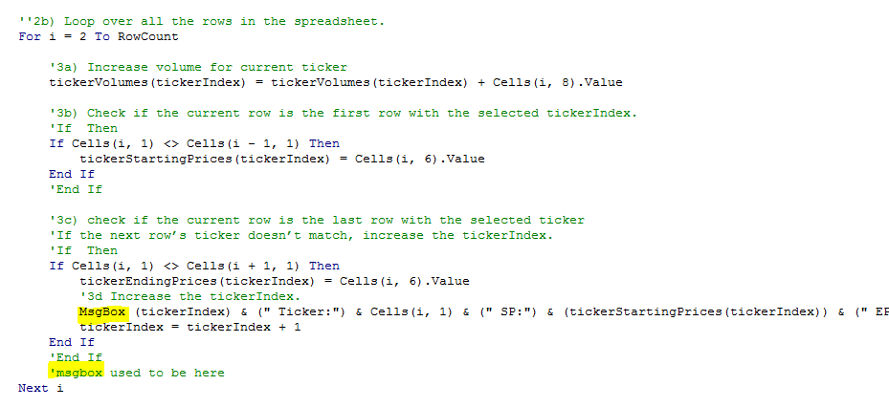

**Other Challenges:**

The order of the instructions made it a bit difficult to conceptualize the flow of the code.

The instructions advised to use a variable tickerIndex which doesn’t change values until the code in instruction 3d, therefore, I had a hard time to visualize how the values in each of the prior code would be filled while I was following along chronologically.

I was able to overcome this by following the instructions backwards, starting from step 4 which better helped me conceptualize how the data needed to be presented and how the tickerIndex value changed.

Additionally in troubleshooting my infinite loop challenge, I created a table (see above) that shows the flow of the loop/code in non-coding language and created a new sheet which presented this in the format of Excel formulas, both which I am much more familiar with. By seeing the flow of the code in these ways I was able to better understand what was happening with the code.

How to stop VBA program: <https://stackoverflow.com/questions/10114447/excel-vba-break-execution-when-theres-no-break-key-on-keyboard/10200371#:~:text=I%20have%20an%20HP%20laptop,msgbox%20and%20code%20will%20break.&text=Hold%20CTRL%20%2B%20Fn%20%26%20hit%20Shift,of%20my%20HP%20Pavilion%20G7>.